PROJECT-STOR2RRD

ORGANISATION-STOR2RRD

INTRODUCTION:

STOR2RRD is an open-source software tool that is used for monitoring and reporting performance in storage systems, SAN switches, and LAN switches. It is developed by the Czech company**XoruX**.

THE LATEST VERSION FOR STOR2RRD IS

STOR2RRD is open-source software [5] that is published under the GNU General Public License v3.0. As of November 2021, the latest version is 7.30. [6] [7] Beta versions were initially made available in 2013.

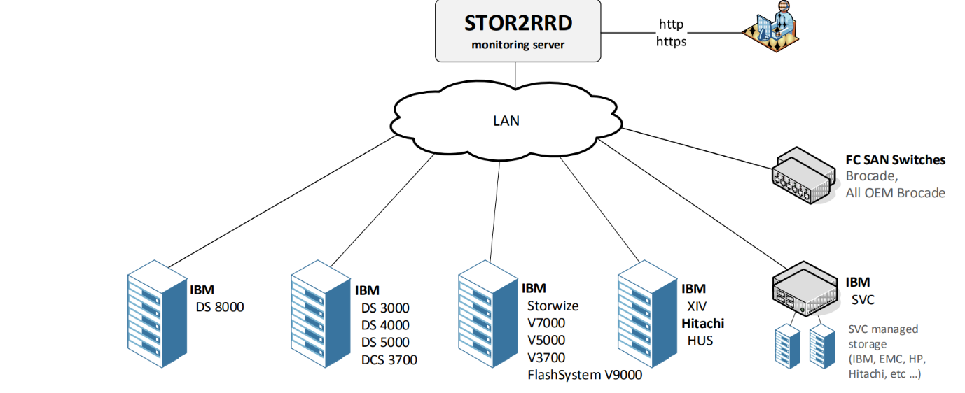

PROJECT SUMMARY

|  |  |
| --- | --- |
| Website | stor2rrd.com |
| Organisation/foundation name | STOR2RRD |
| License | [GNU General Public License](https://www.bing.com/ck/a?!&&p=ae1c941ed8911edbJmltdHM9MTY3NTAzNjgwMCZpZ3VpZD0wYmNjNmZkOC1lY2M2LTZhMzAtMTNjMC03ZWZmZWQ2YjZiNDUmaW5zaWQ9NTQyNw&ptn=3&hsh=3&fclid=0bcc6fd8-ecc6-6a30-13c0-7effed6b6b45&u=a1L3NlYXJjaD9xPUdOVStHZW5lcmFsK1B1YmxpYytMaWNlbnNlK3dpa2lwZWRpYQ&ntb=1) v3.0 |
| Open/proprietary | Open source project |
| Source path | <https://github.com/XoruX/stor2rrd> |
| Brief description | STOR2RRD is an open-source software tool that is used for monitoring and reporting performance in storage systems, SAN switches, and LAN switches. It is developed by the Czech company**XoruX**  STOR2RRD is open-source software [5] that is published under the GNU General Public License v3.0. |

PROJECT DETAILS

Key features:

* Lan
* Local Area Network

It is an abbreviation for**Local Area Network**. It connects various network devices in a way that the workstations and PCs

* Ceph

Ceph is an open-source software-defined storage platform that implements object storage on a single distributed computer cluster and provides 3-in-1 interfaces for object-, block- and file-level storage.

* Datacore

DataCore, also known as DataCore Software, is a Fort Lauderdale, Florida-based developer of software-defined storage.

* Dell

Designed from the ground up for virtualized environments, Dell’s modern storage architecture is scalable, easily enhanced, and uncoupled from the limitations of any legacy architecture with intelligent tiering and innovative licensing.

* Dot hill

Computer storage area network arrays

The Dot Hill 3930 Storage Array is a 12-drive multiprotocol

* Falconstor

Founded in 2000, FalconStor provides a software solution designed to modernize and optimize data protection for the hybrid cloud world. Leadership FalconStor’s leadership team is comprised of enterprise software and data protection industry veterans.

Are some of the key features of stor2rrd project

ARCHITECTURE:

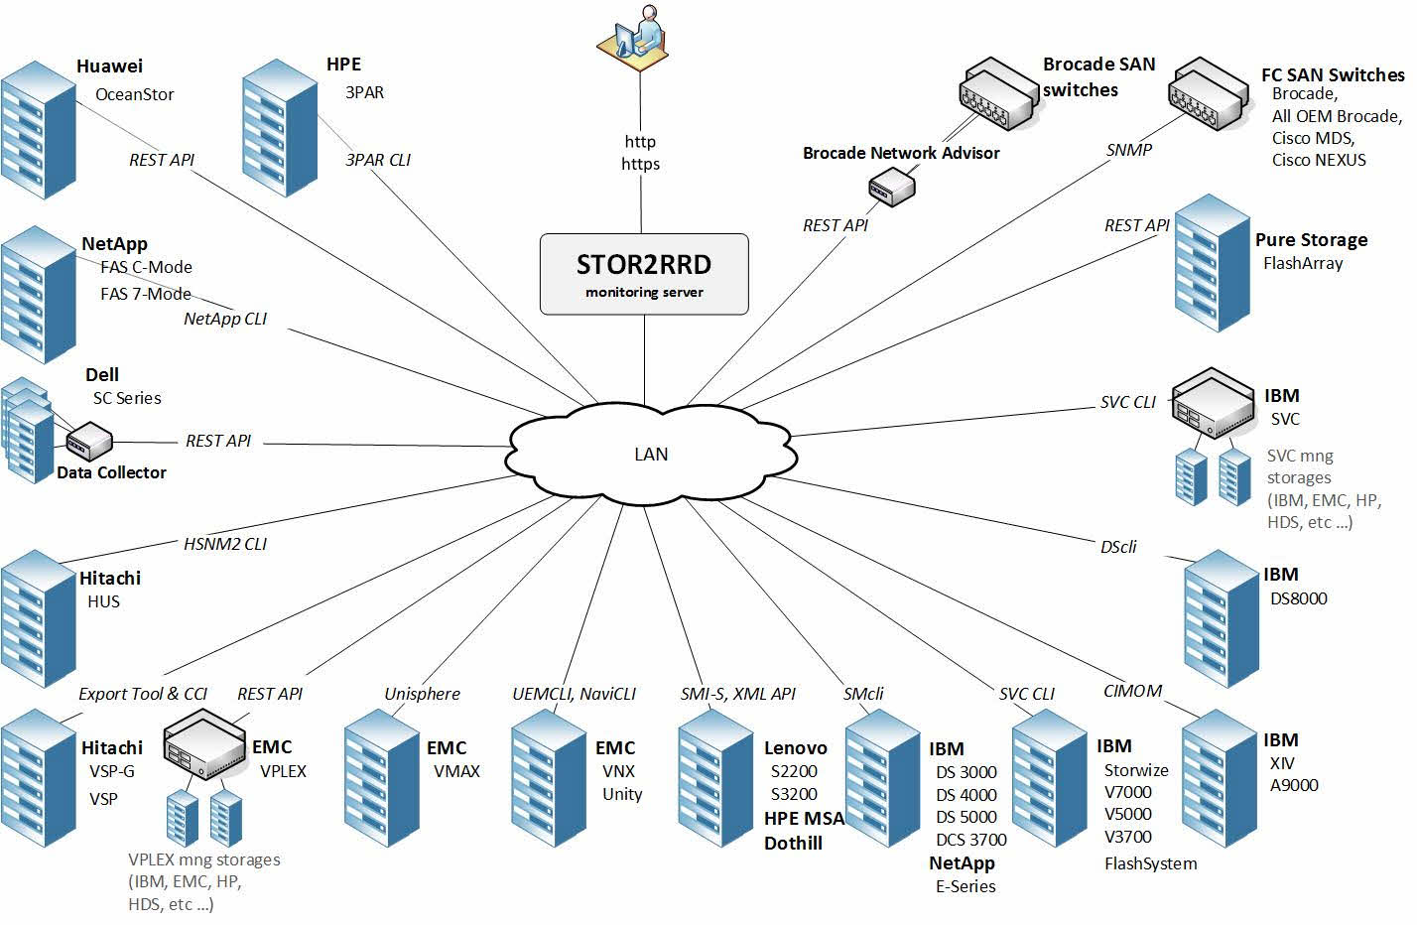

CURRENT USAGE:

• IBM Storwize V7000, V5000, V3700

• IBM SVC

• IBM FlashSystem V9000

• IBM System Storage DS8000 and DS6800

• LSI / Engenio based storages

TECHNICAL DETAILS:

The tool is able to provide base for your storage accounting based on allocated data in the time.  
Capacity allocation data is stored per:

* Pool
* Tier
* Volume

Capacity data is stored every hour.  
  
Customers with premiumsupport subscription can use a framework which exports capacity allocation data from the tool in the format required by each customer.  
  
Output format options:

* CSV
* XLS
* JSON
* XML
* PDF
* Graphical in the UI

Further reporting options:

* Raw capacity allocation (include RAID and spare disk overhead)
* Automated creation and either saving in defined location or sending via email
* One or more defined storage in single report
* Daily/weekly/monthly or custom date based reports
* REST API

**Examples**

* EXCEL REPORTS

PROJECT COMPARISION

* LPAR2RRD

**LPAR2RRD** is an open-source software tool that is used for monitoring and reporting performance of servers, clouds and databases. It is developed by the Czech company XoruX.

LPAR2RRD is open source software that is published under the GNU license . As of April 2022, the latest version is 7.40. The software was first launched in 2006.

The software tool is designed to monitor and report on server visualization utilizations. It produces utilization graphs, reports, or alerts of physical or virtual servers on CPU, memory, IOPS, and many other depending on specific virtualization platform. It also supports database engines as oracle database, postgresql or containerization platforms like openshift or docker. Cloud technologies are supported as well.

OTHER INFORMATION:

STOR2RRD is a performance monitoring and capacity planning tool for storage and SAN, which monitors all your storage devices within one centralized console. All required information regarding your disk arrays, ports, pools, ranks, mdisks, volumes and drives are presented in a simple understandable form on your STOR2RRD console. You can easily find out actual and historical performance data (to track issues and bottlenecks) and quickly respond to any performance problem. It is able to aggregate performance information for group of volumes across your environment (regardless of storage unit).

THE latest versions of stor2rrd:

• IBM FlashSystem V9000 support

• Alerting based on performance thresholds

FUTURE PLANS ENHANCEMENT:

• support for EMC, Hitachi, HP and NetApp storages

• LPAR2RRD and STOR2RRD integration